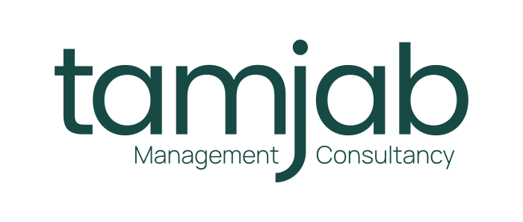
CONCEPT NOTE • CLIENT OVERVIEW
From potential
to meaningful impact.
A practical introduction to how Tamjab helps organisations, founders and leaders build clarity, trust, relationships and sustainable growth.

Strategy · Communications · Sustainability · Growth
For organisations ready to connect good ideas with the people, systems and opportunities that move them forward.
02 THE OPPORTUNITY
Good work deserves
to be understood.
Organisations rarely lack ideas, commitment or expertise. The challenge is turning them into clarity, trust, relationships and opportunity.

Does this sound familiar?
- Your offer is valuable, but difficult to explain.  - Different teams communicate the organisation differently.  - Strong work is not producing enough visibility or demand. | - Stakeholders hear from you, but do not feel meaningfully engaged.  - Growth plans are not translating into consistent execution.  - A sensitive issue could test trust before the team is ready.
Tamjab helps connect the pieces — so strategy, communications, people and systems reinforce one another.
03 OUTCOMES
Start with the change
you need to see.
We shape the work around outcomes, not a pre-set package.
01  Positioning  Make your value unmistakable in crowded or changing markets.  - Clarify your relevance  - Translate complexity  - Align internal and external language | 02  Growth  Turn strategic intent into sustainable momentum and opportunity.  - Connect visibility to demand  - Close execution gaps  - Build systems for the next stage
03  Reputation  Strengthen credibility before trust is tested.  - Create message consistency  - Prepare for scrutiny and change  - Make impact easier to recognise | 04  Engagement  Move beyond broadcasting to relationships that create value.  - Understand key stakeholders  - Build dialogue around real needs  - Turn attention into advocacy
04 WHAT WE DO
Five connected
service areas.
One organisational challenge can cross several disciplines. Tamjab brings the right combination together.
01 | Strategic Communications  Clarity, stories and communications systems that support trust and organisational goals. | Strategy · Audits · Content · Fundraising communications
02 | Leadership Visibility  Make useful expertise easier to find, trust and remember. | Executive positioning · Thought leadership · LinkedIn · Authority
03 | Strategy & Advisory  Make sense of direction, priorities and how the pieces connect. | Organisational strategy · Growth · Diagnostics · Partnerships
04 | Sustainability & Responsible Growth  Connect purpose and impact to how the organisation creates value. | Sustainability · ESG communications · Stakeholders · Impact positioning
05 | People & Capability  Build the skills and systems needed to perform and grow. | Leadership training · Workforce readiness · Talent · Capacity building
Crisis Communications
Preparedness and response sit across the model: helping leaders communicate quickly, maintain message discipline, protect stakeholder confidence and support reputation recovery when pressure is high.
05 HOW WE WORK
Connected thinking.
Practical movement.
The Tamjab model
Think → Position → Communicate → Connect → Grow
Positioning shapes reputation. Reputation shapes trust. Trust creates relationships. Relationships create opportunity.
A typical engagement can begin with
01 Diagnose  Clarify the challenge, context, stakeholders and current gaps. | 02 Define  Agree priorities, outcomes and the most useful starting point.
03 Design  Build the strategy, messages, systems or learning experience. | 04 Deliver & strengthen  Support execution, capability and the next practical decisions.
Ways to start
A diagnostic or audit • A focused strategy project • Ongoing advisory • A team workshop or masterclass
06 SELECTED WORK
Evidence through
real-world challenges.
  Taskers  Turning everyday help into a trusted service  Tamjab explored how strategy, positioning, communications and customer experience could bring trust, convenience, people and technology together.  Contribution: positioning, service messaging, customer-focused thinking and growth. |   Jacob Hopes Foundation  Turning personal loss into action  Tamjab supported programme strategy, stakeholder engagement and collaboration connecting patients, regional actors and Cameroonian medical expertise in the diaspora.  Contribution: partnerships, advocacy, health communications and social impact strategy.
Selected experience includes GIZ, Diageo, Caritas, Plan International, GreenFaith, ISHR, Engagement Global and Piron.
07 FIT & ECOSYSTEM
Built for work
that crosses boundaries.
Who we work with
Technology • Healthcare • Nonprofits and social impact • FMCG and consumer brands • Banking and financial services • Founders and social entrepreneurs • Professional services
Specialist solutions within the Tamjab ecosystem
Build Comms  Communications infrastructure | Comms System Audit  Communications diagnostic
WorkReady Africa  Talent and workforce readiness | Communications for Impact  Capacity building for impact organisations
Tamjab Masterclass
Practical professional learning
08 NEXT STEP
 | Meet the founder  Irene Bonjeh Azong-Wara  Management Consultant · Strategic Communications · Sustainability  Irene brings more than 15 years of experience across communications, strategy, sustainability, social impact and stakeholder engagement.
Let’s find the clearest
place to begin.
Bring the challenge as it is. A clarity conversation can help define what matters now, where the gaps sit and which Tamjab service or next step is most relevant.
Book a clarity call
cal.com/irene-bonjeh/clarity-call
Connect
www.tamjab.org Website
Chat with us on WhatsApp
irene-bonjeh.com Meet Irene
Transforming potential into impact.

